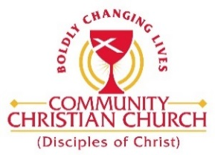
Community Christian Church
Building Use/Calendar Date Request
(use for church-sponsored events)

Date of Request: Click here to enter text.
Event: Click here to enter text.
Group: Click here to enter text.

Date(s) Requested: Click here to enter text.
Set-Up Time: Click here to enter text.
Start Time: Click here to enter text.
End Time: Click here to enter text.

Room(s) Requested (please check):
Room |  | Room |  | Room
Narthex | ☐ | Upper Packwood Rm. 206/208 | ☐ | Lower Packwood Rm. 105 | ☐
Sanctuary | ☐ | Office Suite B | ☐ | Wunderlich Gym | ☐
Upper Packwood Rm. 202 | ☐ | DeWitt Hall | ☐ | Wunderlich Kitchen | ☐
Upper Packwood Rm. 204 | ☐ | DeWitt Kitchen | ☐ | Wunderlich Classroom | ☐
Library | ☐ | Click here to enter text. | ☐ | Click here to enter text. | ☐

Multimedia Needed: ☐ Yes ☐ No ☐ TBD
Childcare Needed: ☐ Yes ☐ No ☐ TBD

Special Requests (tables, chairs, microphones, etc.): Click here to enter text.

Contact Name: Click here to enter text.
Phone Number: Click here to enter text.

(If you need specific arrangements of tables, chairs, etc., please draw layout on back of this form)

For Office Use:
Approved by: Click here to enter text.
Date: Click here to enter text.
Placed on CCC Calendar on: Click here to enter text.

